# Question 1

#include <stdio.h>

int main() {

int n, i, sum = 0;

printf("Enter the number of elements in the array: ");

scanf("%d", &n);

int arr[n];

printf("Enter %d elements: \n", n);

for (i = 0; i < n; i++) {

printf("Enter element %d: ", i+1);

scanf("%d", &arr[i]);

}

for (i = 0; i < n; i++) {

sum += arr[i];

}

printf("Sum of array elements: %d\n", sum);

return 0;

}

# QUESTION 2

#include <stdio.h>

int main() {

int n, i, key, found = 0;

printf("Enter the number of elements in the array: ");

scanf("%d", &n);

int arr[n];

printf("Enter %d elements: \n", n);

for (i = 0; i < n; i++) {

printf("Enter element %d: ", i+1);

scanf("%d", &arr[i]);

}

printf("Enter the element to search: ");

scanf("%d", &key);

for (i = 0; i < n; i++) {

if (arr[i] == key) {

printf("Element %d found at position %d\n", key, i + 1);

found = 1;

break;

}

}

if (!found) {

printf("Element %d not found in the array.\n", key);

}

return 0;

}

# QUESTION 3

#include <stdio.h>

int main() {

int n, i;

printf("Enter the number of elements in the array: ");

scanf("%d", &n);

int arr[n];

printf("Enter %d elements: \n", n);

for (i = 0; i < n; i++) {

printf("Enter element %d: ", i+1);

scanf("%d", &arr[i]);

}

printf("Array in reverse order: ");

for (i = n - 1; i >= 0; i--) {

printf("%d ", arr[i]);

}

printf("\n");

return 0;

}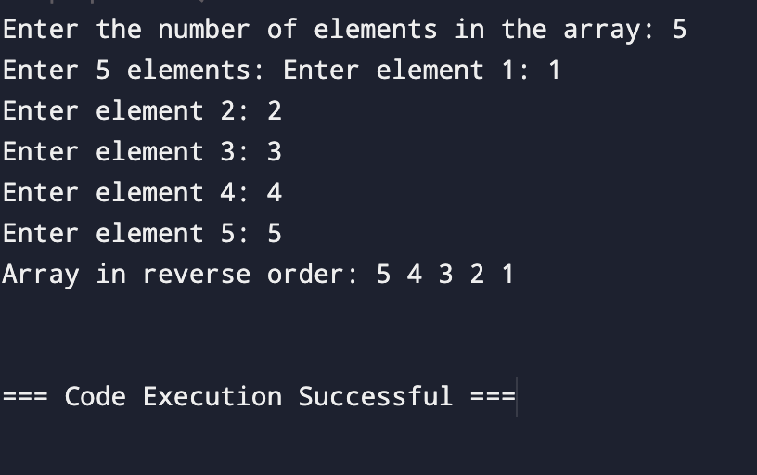

# QUESTION 4

#include <stdio.h>

int main() {

char name[100];

char id[20];

int i, valid, age;

printf("Enter your name: ");

gets(name);

valid = 1;

for (i = 0; name[i] != '\0'; i++) {

if (!((name[i] >= 'A' && name[i] <= 'Z') || (name[i] >= 'a' && name[i] <= 'z') || name[i] == ' ')) {

valid = 0;

break;

}

}

if (valid)

printf("Valid Name: %s\n", name);

else

printf("Invalid name! Only alphabetic characters and spaces are allowed.\n");

printf("Enter your age: ");

scanf("%d", &age);

if (age >= 1 && age <= 120) {

printf("Valid Age: %d\n", age);

} else {

printf("Invalid age! Age should be between 1 and 120.\n");

}

printf("Enter your ID number: ");

scanf("%s", id);

valid = 1;

for (i = 0; id[i] != '\0'; i++) {

if (!(id[i] >= '0' && id[i] <= '9')) {

valid = 0;

break;

}

}

if (valid)

printf("Valid ID Number: %s\n", id);

else

printf("Invalid ID number! Only digits are allowed.\n");

return 0;

}

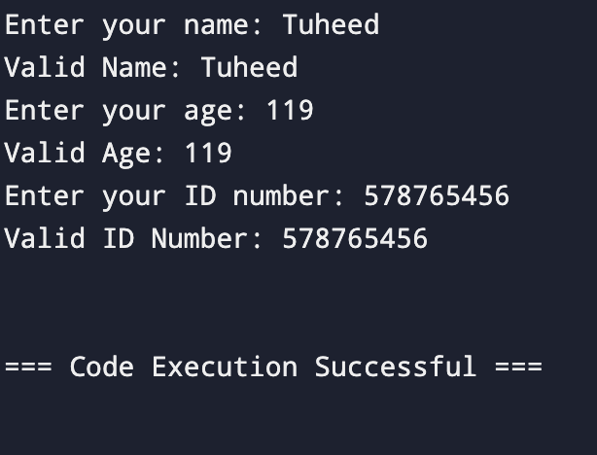

# QUESTION 5

#include <stdio.h>

int main() {

int size;

printf("Enter the size of the array: ");

scanf("%d", &size);

int arr[size];

printf("Enter %d elements:\n", size);

for (int i = 0; i < size; i++) {

printf("Enter elements %d: ", i+1);

scanf("%d", &arr[i]);

}

int min = arr[0];

int max = arr[0];

for (int i = 1; i < size; i++) {

if (arr[i] < min) {

min = arr[i];

}

if (arr[i] > max) {

max = arr[i];

}

}

printf("Minimum Number = %d\n", min);

printf("Maximum Number = %d\n", max);

return 0;

}

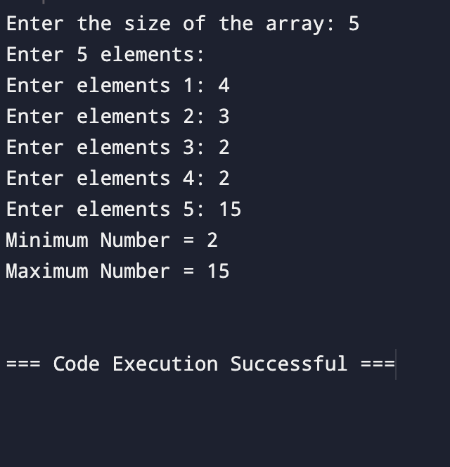

# QUESTION 6

#include <stdio.h>

int main() {

float temperatures[7];

float sum = 0;

float average = 0;

int extremeDays[7] = {0};

int extremeCount = 0;

printf("Enter the temperatures for 7 days:\n");

for (int i = 0; i < 7; i++) {

printf("Day %d: ", i + 1);

scanf("%f", &temperatures[i]);

sum += temperatures[i];

if (temperatures[i] > 40 || temperatures[i] < 0) {

extremeDays[extremeCount++] = i + 1;

}

}

average = sum / 7.0;

printf("Average temperature: %.1f°C\n", average);

if (extremeCount > 0) {

printf("Extreme temperatures on day(s): ");

for (int i = 0; i < extremeCount; i++) {

printf("%d ", extremeDays[i]);

}

printf("\n");

} else {

printf("No extreme temperatures recorded.\n");

}

return 0;

}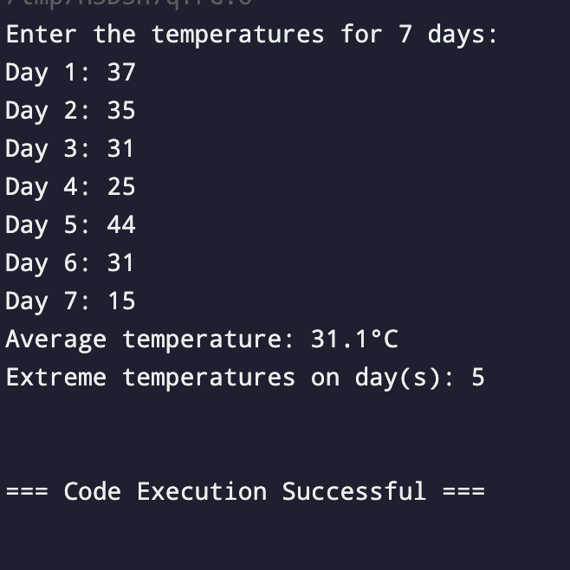

# QUESTION 7

#include <stdio.h>

void findDuplicates(int arr[], int size) {

int count[size];

for (int i = 0; i < size; i++) {

count[i] = 0;

}

for (int i = 0; i < size; i++) {

count[arr[i]]++;

}

printf("Numbers that occur more than once: ");

int found = 0;

for (int i = 0; i < size; i++) {

if (count[i] > 1) {

printf("%d ", i);

found = 1;

}

}

if (!found) {

printf("No duplicates found.");

}

printf("\n");

}

int main() {

int size;

printf("Enter array size: ");

scanf("%d", &size);

int arr[size];

for (int i = 0; i < size; i++) {

printf("Element %d = ", i + 1);

scanf("%d", &arr[i]);

}

findDuplicates(arr, size);

return 0;

}

